**Team 1:**

**Medicine Finder**

Medicine finder is a simple pharmaceutical searching application which provides ability to find medicine near customers location. Basic features of the application are follows,

* Pharmaceutical/Individual’s agencies should be able to register to the system. Email verification required
* Pharmaceutical/Individual’s agencies should be able to log into the system
* Pharmaceutical/Individual’s agencies should be able to add their location to the system using real map.
* Pharmaceutical/Individual’s agencies should be able to add drugs and related information to the system.
* Pharmaceutical/Individual’s agencies should be able to remove/update and view all the products they have added
  + Pharmaceutical/Individual’s agencies should be getting recommendation on top 10 selling products.
* Customers should be able to register and log into the system. Email verification required
* Customers should be able to search medicine store based on the location and drug availability.
* Customers should be getting suggestions on similar products with same generic name instead of brand name.
* If customer not able find drug, should be able to add the drug information to the system and when the drug is available, customer should be getting email notification [optional]

**Timeline**

|  |  |  |
| --- | --- | --- |
| **Req. Analysis** | 3hrs |  |
| **Design** | 4hrs |  |
| Select technologies | 1hr |  |
| Draw diagrams | 1hr |  |
| DB Design | 2hrs |  |
| **Implementation** |  |  |
| Setup coding env. | 4hrs |  |
| Agency module | 12hrs |  |
| * frontend | 4hrs |  |
| * UI | 2hr |  |
| * Backend | 6hrs |  |
| Customer module | 10hrs |  |
| Product module | 12hrs |  |
| Authentication (login) | 5hrs |  |
| Recommendation | 4hrs |  |
| Notification | 4hrs |  |
| Additional Buffer |  |  |

**Tech stack**

Backend: Spring Boot

Database: MySql

Frontend: ReactJS

Architecture: Layered Architecture

**Diagrams**

Use case

Sequence diagram

* **Usecase**

Pharmacy

Register

Login

Add Location

Add Drugs n related info

Update n view Drugs

Get recommendations

Customer

Register

Login

Search Medicine

Get suggestions

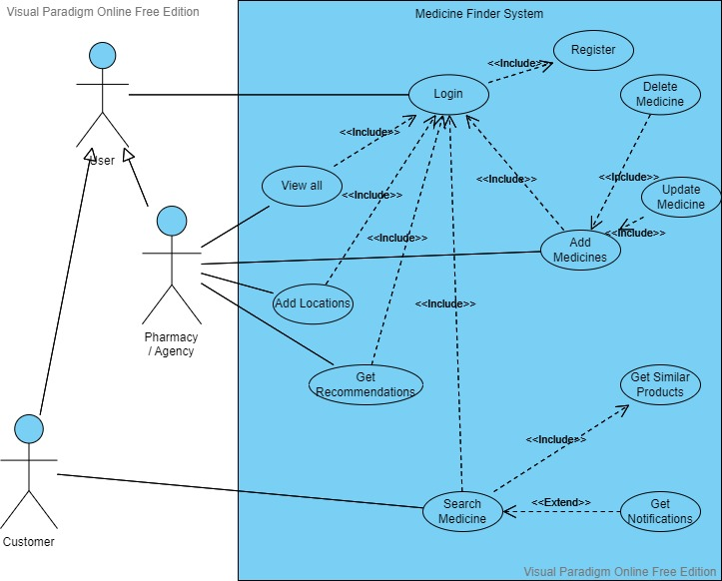Get notifications

**Tables**

Customer

Customer Name

Email

Pharmacy/agency

Pharmacy Name

Address (Main Loc.)

Contact No.

Email

License No.

Product

Generic Name

Brand Name

Price

License no.

Description

Search index

Create Acc.:

Email

Pw.

Verify pw.

Register Pharmacy:

Pharmacy Name

Address (Main Loc.)

Contact No.

Email

License No.

Add Branch:

Branch name

Address

Add medicine:

Medicine name

Brand name

License no.

Price

Description

Create Acc.:

Username

Email

Pw.

Verify pw.

Search medicine:

Medicine(brand/medicine) Name

Location